**(Elastic Container Service) ECS – Part 1 - Docker**

**Typical Application stack:**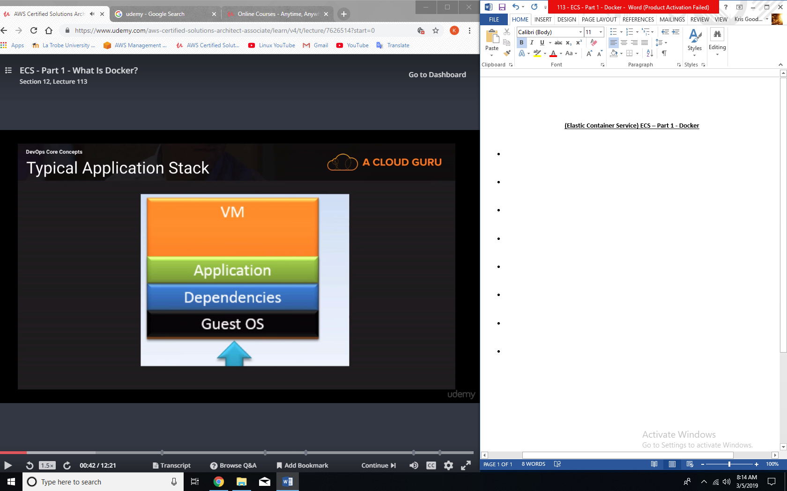

**What is Docker?**

* Docker is a software platform that allows you to build, test, and deploy applications quickly.
* Docker is highly reliable: you can quickly deploy and scale applications into any environment and know your code will run.
* Docker is infinitely scalable: running Docker on AWS is a great way to run distributed applications at any scale.
* Docker packages software into standardized units called Containers:
  + Containers allow you to easily package an application’s code, configurations, and dependencies into easy to use building blocks that deliver environmental consistency, operational efficiency, developer productivity, and version control.

**Virtualization vs Containerization:**

* Traditional Virtual Machine.
* Container.
* And that’s where the technologies diverge.
* Traditional virtualization has density compromises.
* Docker achieves higher density, and improved portability by removing the per container Guest OS.  
  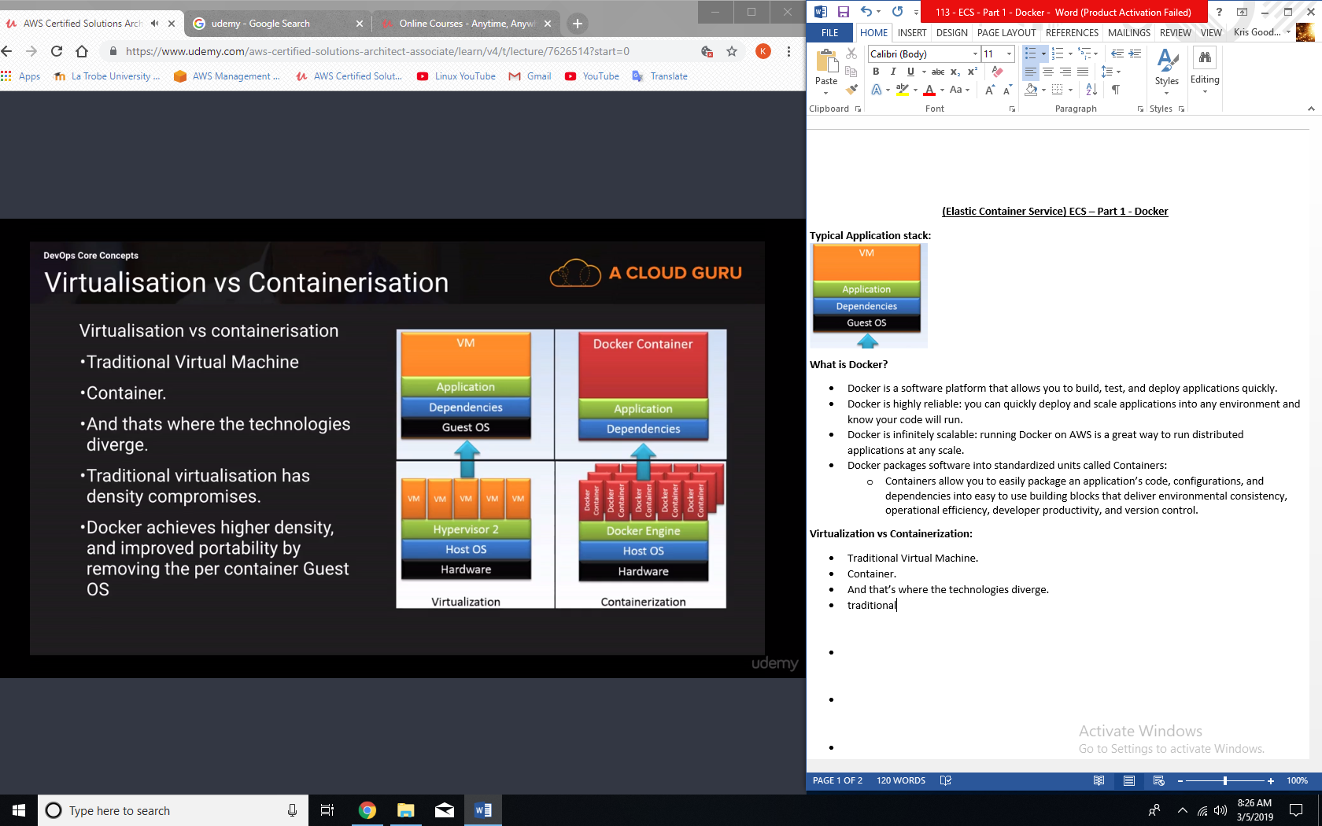

**Containerization Benefits:**

* Escape from dependency hell.
* Consistent progression form DEV -> TEST -> QA -> PROD.
* Isolation – performance or stability issues with app A in container A, wont impact App B in container B.
* Much better resource management.
* Extreme code portability
* Micro-Services.

**Docker Components:**

* Docker Image.
* Docker Container.
* Layers / Union File System.
* DockerFile.
* Docker Daemon / Engine.
* Docker Registries / Docker Hub.

**About ECS**

* Amazon EC2 Container Server (ECS) is a highly scalable, fast, container management service that makes it easy to run, stop and manage Docker containers on a cluster of EC2 instances. Amazon ECS lets you launch and stop container-based applications with simple API calls, allows you to get the state of your cluster from a centralized service, and gives you access to many familiar Amazon EC2 features.